


Data Compliance Test (DCT)
Test Cases for
Clinical Note Summary Record

<HCP Name>

Table of Contents
1 Testing Instructions to HCPs 3
1.1 Self-Service Testing Phase 3
1.2 Final Testing Phase 3
1.3 Preparation DCT Test Report 4
2 Test Case Details 5
EPIS-001 5
EPIS-002 8
3 Appendix – Sample Messages 12
4 Appendix – Testing HCP and HCRs Information 14
5 Appendix – Sample Results in eHR Viewer (EVE) 14

Testing Instructions to HCPs

Self-Service Testing Phase
- After development of the data upload programmes, you can use the Self-Service test accounts and test HCRs provided by eHealth for connection to the eHealth testing environment and proceed with the self-service testing.
- You can proceed with the Self-service test at your own pace by following this Self-Service Testing Guide and using the test cases provided in section 2.
- You can verify the correctness and completeness of the data upload by:
- checking the interface files / messages generated in your system against the sample expected results of interface files /messages for all test cases as provided;
- checking the results on eHR Viewer (EVE) by logging into the testing eHealth with the provided test account; and
- checking the upload status through Process Summary and Exception Report in eHR Inbox by logging into the testing eHealth.
- For data fields requiring eHR Codex values, you can refer the Code Sets provided with the Self-Service Kit.
- For details of technical requirements of the data interface files, please refer to the Developer Quick Guide for Clinical Note Summary Upload to eHealth.docx
- You are required to perform the test cases that are relevant to the data compliance level (Level 1) supported by your clinic.
- You are required to perform the first batch of data upload by Data Materialization (DM) mode. DM mode is denoted in the interface by a fixed value BL-M in HL7 OBX.4
- You should use Incremental Load (INC) mode for the second batch of data upload to update the previously uploaded records. INC mode is denoted in the interface by a fixed value BL in HL7 OBX.4.
- Since the DM mode would replace the corresponding records previously uploaded to eHealth, you may repeat your testing unlimited number of times by uploading the first batch by DM mode.
- It should be noted that the data field “Record Key” should be unique for each clinical note/summary record.
- When all required test cases can be completed smoothly and correctly in this phase, you can proceed to the Final Testing Phase and submit production environment setup form to eHR DCT Support for preparation.

Final Testing Phase
- You can start the Final Testing Phase once all test cases in the Self-Service Testing phase are passed.
- You should start Final Test by executing the test cases provided in section 2 with Final Testing HCRs provided by eHR DCT Support.
- You can verify the correctness and completeness of testing results by checking results in eHR Viewer (EVE) and the upload status through Process Summary and Exception Report in eHR Inbox.
- For Clinical Note Summary DCT test cases, there are TWO batches of data files / transactions to be uploaded to the testing eHealth. The required records must be correctly uploaded from these 2 consecutive batches respectively.
- The Final Test will be considered PASSED if all the following criteria are met:
- The TWO batches of test data files are uploaded consecutively in the correct sequence. The second batch of data files/transactions must be submitted after completion of processing of the first batch by eHealth
- No additional data files / transactions are uploaded in between or after the uploads of the above two batches of data files / transactions to amend any records.
- No exception records are reported from the uploads.
- No manual interventions have been made to the data files / transactions.
- If the Final Test failed, you can re-attempt the Self-Service Test and Final Test until a successful run can be completed.

Preparation DCT Test Report
- Once you have successfully passed the Final Test based on the above criteria, you should complete this document by attaching the below items to this document at the appropriate space provided:
  - Actual data files uploaded
  - Screen-shot of each test case
- You are required to submit this completed ‘DCT Test Cases’ document to eHR DCT Support for further processing. eHR DCT Support will provide feedback within 10 working days.

Test Case Details
1 | Test Case ID | EPIS-001
 | Function Description | HCP has received the sharing consents from testing HCRs, then perform first data upload of HCRs’ clinical records to eHealth by DM Mode for Level 1 data.
 | Subsequent case of | N/A
 | Testing Assumption | - HCR1-HCR4 have already given sharing to sharing consent to the HCP.  - The EMR system will upload Batch 1 data files to eHealth with all clinical note summary records of <HCR1> - <HCR4> created by DM mode.
 | Test Actions | HCP creates below clinical note summary records in EMR system:
 | Test Actions | 1a | Case scenario: Input new Primary Care Consultation Note for <HCR1> in EMRS for PDF report generation as follows:  - Report start date = 01-Jun-2023 10:00:00  - Type of clinical setting local description = Outpatient record  - Clinical note / summary report title = Primary Care Consultation Note  - Clinical note / summary report date = 01-Jun-2023 11:00:00  - Clinical note / summary highlight = Knee Pain  Expected data contents for Level 1 interface record:  - Report start date = 01-Jun-2023 10:00:00  - Type of clinical setting code = OP  - Type of clinical setting description = Outpatient record  - Type of clinical setting local description = Outpatient record  - Report entity identifier = 102888  - Clinical note / summary report title = Primary Care Consultation Note  - Clinical note / summary report date = 01-Jun-2023 11:00:00  - Clinical note / summary report (PDF) File Indicator = 1  - File name = [follow naming standards as specified in General Guide]  - Generated PDF report with the above data and file name  - Clinical note / summary highlight = Knee Pain
 | Test Actions | 1b | Case scenario: Input new Discharge summary for <HCR2> in EMRS for PDF report generation as follows:  - Report start date = 01-Jul-2023 10:00:00  - Report end date = 02-Jul-2023 11:00:00  - Type of clinical setting local description = In-patient record  - Clinical note / summary report title = Discharge summary  - Clinical note / summary report date = 02-Jul-2023 11:00:00  - Clinical note / summary highlight = Urology  - Clinical note / summary remark = DCT test case  Expected data contents for Level 1 interface record:  - Report start date = 01-Jul-2023 10:00:00  - Report end date = 02-Jul-2023 11:00:00  - Type of clinical setting code = IP  - Type of clinical setting description = Inpatient record  - Type of clinical setting local description = In-patient record  - Report entity identifier = 102103  - Clinical note / summary report title = Discharge summary  - Clinical note / summary report date = 02-Jul-2023 11:00:00  - Clinical note / summary highlight = Urology  - Clinical note / summary remark = DCT test case  - Clinical note / summary report (PDF) File Indicator = 1  - File name = [follow naming standards as specified in General Guide]  - Generated PDF report with the above data and file name
 | Test Actions | 1c | Case scenario: (Only applicable for Level 1 data upload without PDF report)  Input new CRC Screening Summary for <HCR3> in EMRS for Text report generation as follows:  - Report start date = 01-Aug-2023 10:00:00  - Report end date = 01-Aug-2023 11:00:00  - Type of clinical setting local description = Outpatient record  - Clinical note / summary report title = CRC Screening Summary  - Clinical note / summary report date = 11-Aug-2023 11:00:00  Expected data contents for Level 1 interface record:  - Report start date = 01-Aug-2023 10:00:00  - Report end date = 01-Aug-2023 11:00:00  - Type of clinical setting code = OP  - Type of clinical setting description = Outpatient record  - Type of clinical setting local description = Outpatient record  - Report entity identifier = 1006488  - Clinical note / summary report title = CRC Screening Summary  - Clinical note / summary report date = 11-Aug-2023 11:00:00  - Clinical note / summary report (Text) = <Text report with the above data>  - Clinical note / summary report (PDF) File Indicator = 0  - File name = null  - No PDF report generated
 |  | 1d | Case scenario: (Only applicable for Level 1 data upload without PDF report)  Case scenario: Input new Discharge summary for <HCR4> in EMRS for Text report generation as follows:  - Report start date = 01-Sep-2023 10:00:00  - Report end date = 02-Sep-2023 11:00:00  - Type of clinical setting local description = In-patient record  - Clinical note / summary report title = Discharge summary  - Clinical note / summary report date = 02-Sep-2023 11:00:00  - Clinical note / summary highlight = Urology  - Clinical note / summary remark = DCT test case  Expected data contents for Level 1 interface record:  - Report start date = 01-Sep-2023 10:00:00  - Report end date = 02-Sep-2023 11:00:00  - Type of clinical setting code = IP  - Type of clinical setting description = Inpatient record  - Type of clinical setting local description = In-patient record  - Report entity identifier = 102103  - Clinical note / summary report title = Discharge summary  - Clinical note / summary report date = 02-Sep-2023 11:00:00  - Clinical note / summary highlight = Urology  - Clinical note / summary remark = DCT test case  - Clinical note / summary report (Text) = <Text report with the above data>  - Clinical note / summary report (PDF) File Indicator = 0  - File name = null  - No PDF report generated
 | Expected EMR System Behavior | - HCP’s EMR system will upload Batch 1 data files with all investigation report as below scenarios:  - Both ‘PDF’ and ‘TXT’ test cases provided: 1a-1d (Level 1 data) by DM mode.  - Only ‘PDF’ test cases provided: 1a-1b (Level 1 data) by DM mode.  - Only ‘TXT’ test cases provided: 1c-1d (Level 1 data) by DM mode.  - Batch 1 data files should include below files: <samples>  - Participant List (PL)  - Data File (DF)  - HL7 message with signature  - Zip File (embedded PL, DFs and HL7 message files)  - Zip Control File (contains the filenames of PL, DFs and HL7 message)  - EMR system uploads Batch 1 data files (‘Zip File’ and ‘Zip Control File') to eHealth.  - HCP verifies the data upload status by reviewing the 'Process Summary Report' and 'Exception Report' in eHR Inbox.  - HCP verifies the completeness and correctness of data uploaded in eHR Viewer.
 | Results Verification | - HCP verifies the interface file contents and check if the uploaded records can be properly viewed in eHR Viewer (EVE). HCP must also review if the data batches uploaded can be processed successfully or rejected through ‘Process Summary’, ‘Exception Report’ and ‘Re-grade Report’ in eHR Inbox.
 | Actual Result  (Screenshot / Attachment) | Data Files Uploaded:  <Attached the Zip file and Control file>
 | Actual Result  (Screenshot / Attachment) | Attachment/Screenshot:  <Attached the screen shots of records uploaded in eHR Viewers>
 | Remark
 | Testing Date
 | Verified By

2 | Test Case ID | EPIS-002
 | Function Description | There are subsequent changes in HCRs’ clinical records uploaded in Batch 1.  HCP uploads incremental changes to eHealth by INC Mode for Level 1 data.
 | Subsequent case of | EPIS-001
 | Testing Assumption | - HCP has already verified that Batch 1 data have been processed successfully with correct test results.
 | Test Actions | HCP updates clinical note summary records from Batch 1 in EMR system as follows:
 | Test Actions | 2a | Case scenario: Input new Discharge summary for <HCR1> in EMRS for PDF report generation as follows:  - Report start date = 10-Jun-2023 10:00:00  - Report end date = 11-Jun-2023 11:00:00  - Type of clinical setting local description = In-patient record  - Clinical note / summary report title = Discharge summary  - Clinical note / summary report date = 11-Jun-2023 11:00:00  Expected data contents for Level 1 interface record:  - Report start date = 10-Jun-2023 10:00:00  - Report end date = 11-Jun-2023 11:00:00  - Type of clinical setting code = IP  - Type of clinical setting description = Inpatient record  - Type of clinical setting local description = In-patient record  - Report entity identifier = 102103  - Clinical note / summary report title = Discharge summary  - Clinical note / summary report date = 11-Jun-2023 11:00:00  - Clinical note / summary report (PDF) File Indicator = 1  - File name = [follow naming standards as specified in General Guide]  - Generated PDF report with the above data and file name
 | Test Actions | 2b | Case scenario: Update [Report entity identifier], [Clinical note / summary report title], [Clinical note / summary highlight] & [Clinical note / summary remark] of clinical note summary record in 1(a) for <HCR1> in the EMRS as follows:  - Report entity identifier = 1007841  - Clinical note / summary report title = Nursing Outpatient Note  - Clinical note / summary highlight = Blank  - Clinical note / summary remark = DCT test case for UPDATE  Expected data contents for Level 1 interface record:  - Report start date = 01-Jun-2023 10:00:00  - Type of clinical setting code = OP  - Type of clinical setting description = Outpatient record  - Type of clinical setting local description = Outpatient record  - Report entity identifier = 1007841  - Clinical note / summary report title = Nursing Outpatient Note  - Clinical note / summary report date = 01-Jun-2023 11:00:00  - Clinical note / summary highlight = Blank  - Clinical note / summary remark = DCT test case for UPDATE  - Clinical note / summary report (PDF) File Indicator = 1  - File name = [follow naming standards as specified in General Guide]  - Generated PDF report with the above data and file name
 | Test Actions | 2c | Case scenario: Delete clinical note summary record in 1(b) for <HCR2> in the EMRS.  Expected data contents for Level 1 interface record:  - Batch 2 Data file will contain 1 Delete transaction for record 1(b)
 | Test Actions | 2d | Case scenario: (Only applicable for Level 1 data upload without PDF report)  Input new Discharge summary for <HCR3> in EMRS for Text report generation as follows:  - Report start date =20-Aug-2023 10:00:00  - Report end date = 21-Aug-2023 11:00:00  - Type of clinical setting local description = Inpatient record  - Clinical note / summary report title = Discharge summary  - Clinical note / summary report date = 21-Aug-2023 11:00:00  Expected data contents for Level 1 interface record:  - Report start date = 20-Aug-2023 10:00:00  - Report end date = 21-Aug-2023 11:00:00  - Type of clinical setting code = IP  - Type of clinical setting description = Inpatient record  - Type of clinical setting local description = In-patient record  - Report entity identifier = 102103  - Clinical note / summary report title = Discharge summary  - Clinical note / summary report date = 21-Aug-2023 11:00:00  - Clinical note / summary report (Text) = <Text report with the above data>  - Clinical note / summary report (PDF) File Indicator = 0  - File name = null  - No PDF report generated
 | Test Actions | 2e | Case scenario: (Only applicable for Level 1 data upload without PDF report)  Update [Clinical note / summary remark] of clinical note summary record in 1(c) for <HCR3> in the EMRS as follows:  - Clinical note / summary remark = DCT test case for UPDATE  Expected data contents for Level 1 interface record:  - Report start date = 01-Aug-2023 10:00:00  - Report end date = 01-Aug-2023 11:00:00  - Type of clinical setting code = OP  - Type of clinical setting description = Outpatient record  - Type of clinical setting local description = Outpatient record  - Report entity identifier = 1006488  - Clinical note / summary report title = CRC Screening Summary  - Clinical note / summary report date = 11-Aug-2023 11:00:00  - Clinical note / summary remark = DCT test case for UPDATE  - Clinical note / summary report (Text) = <Text report with the above data>  - Clinical note / summary report (PDF) File Indicator = 0  - File name = null  - No PDF report generated
 | Test Actions | 2f | Case scenario: Delete clinical note summary record in 1(d) for <HCR4> in the EMRS.  Expected data contents for Level 1 interface record:  - Batch 2 Data file will contain 1 Delete transaction for record 1(d)
 | Expected EMR System Behavior | - HCP’s EMR system will upload Batch 2 data file with all clinical note summary records as below scenarios:  - Both ‘PDF’ and ‘TXT’ test cases provided: 2a-2f (Level 1 data) by INC mode.  - Only ‘PDF’ test cases provided: 2a-2c (Level 1 data) by INC mode.  - Only ‘TXT’ test cases provided: 2d-2f (Level 1 data) by INC mode.  - Batch 2 data files should include below files: <samples>  - Participant List (PL)  - Data Files (DFs)  - HL7 message with signature  - Zip File (embedded PL, DFs and HL7 message files)  - Zip Control File (contains the filenames of PL, DFs and HL7 message)  - EMR system uploads Batch 2 data files (‘Zip File’ and ‘Zip Control File') to eHealth.  - HCP verifies the data upload status by reviewing the 'Process Summary Report' and 'Exception Report' in eHR Inbox.  - HCP verifies the completeness and correctness of data uploaded in eHR Viewer.
 | Results Verification | - HCP verifies the interface file contents and check if the uploaded records can be properly viewed in eHR Viewer (EVE). HCP must also review if the data batches uploaded can be processed successfully or rejected through ‘Process Summary’, ‘Exception Report’ and ‘Re-grade Report’ in eHR Inbox.
 | Actual Result  (Screenshot / Attachment) | Data Files Uploaded:  <Attached the Zip file and Control file>
 | Actual Result  (Screenshot / Attachment) | Attachment/Screenshot:  <Attached the screen shots of records uploaded in eHR Viewers>
 | Remark
 | Testing Date
 | Verified By

Appendix – Sample Messages
Test Case ID | Step No. | File Type | Bulk Load Format | SOAP Format  (by LAAM)
EPIS-001 | [DM]  [PDF report]  1a – 1b | Participant List (PL)
EPIS-001 | [DM]  [PDF report]  1a – 1b | Data File (DF)
EPIS-001 | [DM]  [PDF report]  1a – 1b | HL7 Message
EPIS-001 | [DM]  [PDF report]  1a – 1b | Zip File | (Password: Abcd1234)
EPIS-001 | [DM]  [PDF report]  1a – 1b | Data File (PDF)
EPIS-001 | [DM]  [PDF report]  1a – 1b | Control File
EPIS-001 | [DM]  [Text report]  1c – 1d | Participant List (PL)
EPIS-001 | [DM]  [Text report]  1c – 1d | Data File (DF)
EPIS-001 | [DM]  [Text report]  1c – 1d | HL7 Message
EPIS-001 | [DM]  [Text report]  1c – 1d | Zip File | (Password: Abcd1234)
EPIS-001 | [DM]  [Text report]  1c – 1d | Control File
EPIS-002 | [INC]  [PDF report]  2a – 2c | Participant List (PL)
EPIS-002 | [INC]  [PDF report]  2a – 2c | Data File (DF)
EPIS-002 | [INC]  [PDF report]  2a – 2c | HL7 Message
EPIS-002 | [INC]  [PDF report]  2a – 2c | Zip File | (Password: Abcd1234)
EPIS-002 | [INC]  [PDF report]  2a – 2c | Data File (PDF)
EPIS-002 | [INC]  [PDF report]  2a – 2c | Control File
EPIS-002 | [INC]  [Text report]  2d – 2f | Participant List (PL)
EPIS-002 | [INC]  [Text report]  2d – 2f | Data File (DF)
EPIS-002 | [INC]  [Text report]  2d – 2f | HL7 Message
EPIS-002 | [INC]  [Text report]  2d – 2f | Zip File | (Password: Abcd1234)
EPIS-002 | [INC]  [Text report]  2d – 2f | Control File

Appendix – Testing HCP and HCRs Information
Sample Message
Self-Service Testing | To be provided by eHR DCT Support later
Final Testing | To be provided by eHR DCT Support later

  - eHR DCT Support will provide other sets of testing HCRs for HCP to perform Self-Service testing and Final testing respectively.

Appendix – Sample Results in eHR Viewer (EVE)
  - After logging on eHR Viewer and searching HCR (the information of HCP is display in the left-hand corner of the top), then click Quick Icon of Clinical Note & Summary or choose Clinical Note & Summary under tree node in menu bar to navigate to Document View in Home Page.
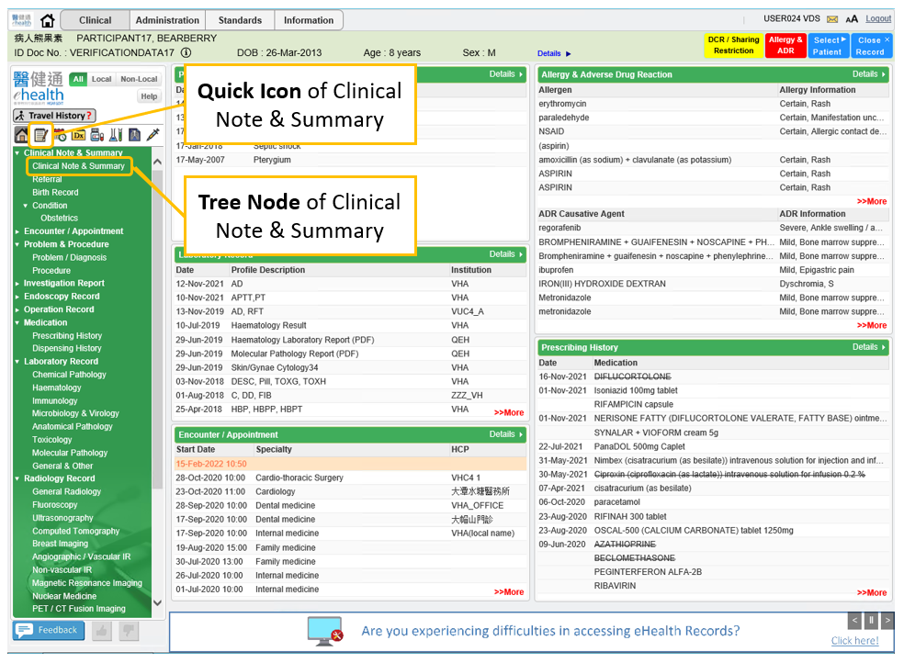
  - In the left-hand panel of Document View page, full list of associated HCR’s records will display while user can filter the record by using ‘Type’ or ‘Period’ dropdown. The default sorting sequence will be:
    - Reverse chronological order of report date, then
    - Alphabetical order of report type, then
    - Alphabetical order of report title
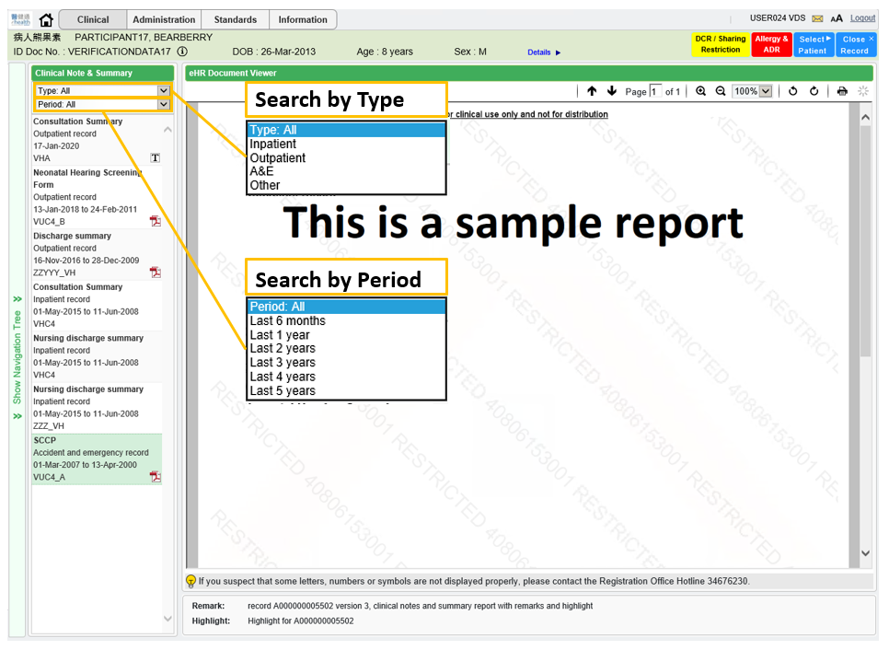

  - For each record in the left-hand panel, each line represents:
    - Report Title
    - Type of clinical setting description
      - eHR description of the type of clinical setting would be shown. If empty, type of clinical setting local description would be shown.
      - If the code of clinical note type sent from health care provider is not matched with eHR standards, it would be mapped to "Other" automatically and local description of clinical notes and summary would be displayed.
    - Report Date (and end date if any)
    - Institution
      - If there is no attending HCI, display name of attending HCP would be shown (Mouse over to show preferred description of HCI/HCP).
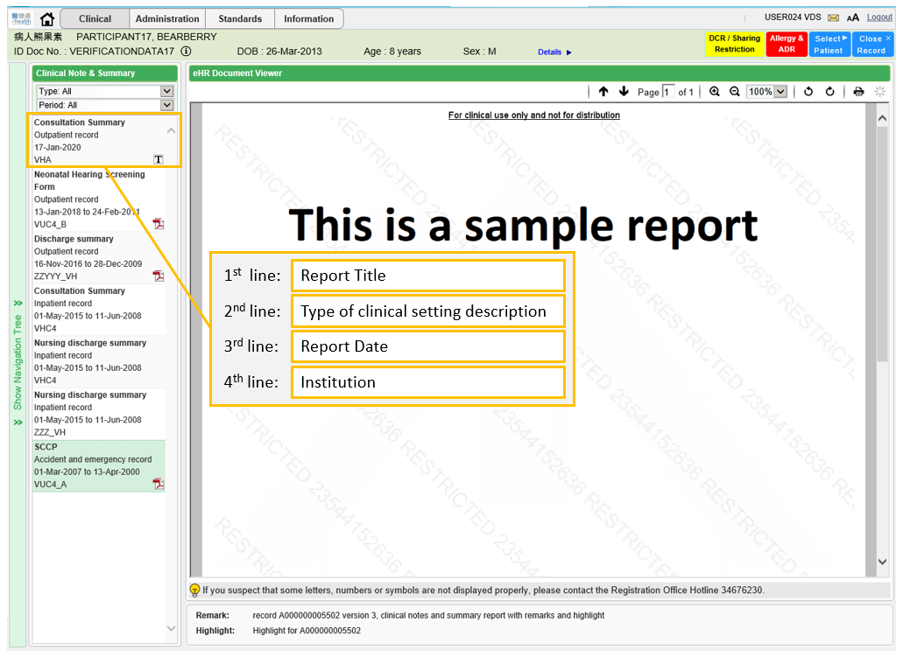

  - By clicking ‘PDF’ icon in the right-hand corner of the record (even record contains both PDF & text document, only ‘PDF’ icon will show) or click corresponding record with ‘PDF’ icon will popup Document Viewer to show the report in the right-hand panel.
In the bottom of the Document View, 1st line is the Clinical Note & Summary Remark while 2nd line is Clinical Note & Summary Highlight (label of remarks or highlight without data value will be suppressed).

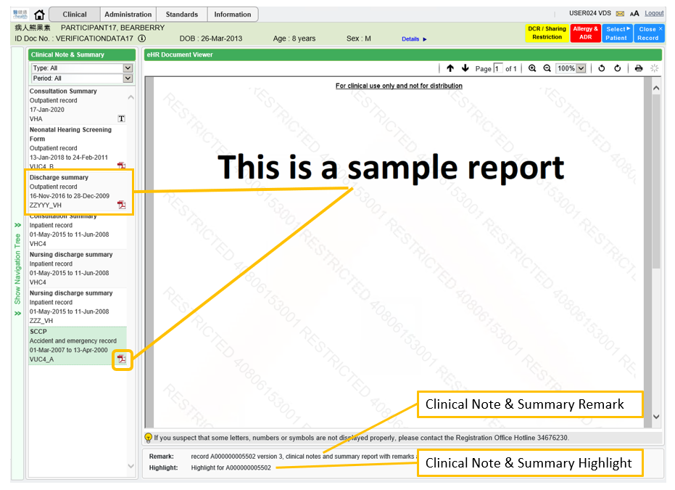

  - By clicking ‘T’ (TEXT) icon in the right-hand corner of the record or click corresponding record with ‘T’ icon will popup Document Viewer to show the textual results in the right-hand panel.

